**Lab2: Processes and Threads**

Student’s name: NGUYEN DANG HUNG

ID: 22IT122

1. Assume that jobs A-D arrive in the ready queue in quick succession and have the CPU cycle requirements listed below. Using the Shortest Remaining Time Next algorithm

a) The average waiting time is [(6-0)+(4-1)+(3-2)+(7-3)]/4=4

b) The Turnaround time of job A is 6

c) The Waiting time of job D is 7.

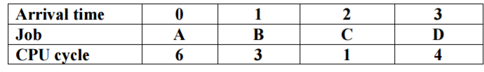

2. A ssume that four jobs A-D require the CPU cycles listed below. Using the Shortest Job First algorithm, the **job B** job is run first.

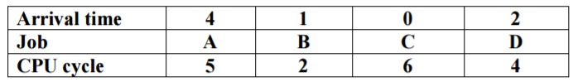

3) A ssume that four jobs A-D require the CPU cycles listed below. Using the Round-Robin algorithm with time slide equaling 4, the average of turnaround time of one process is **6.25**.

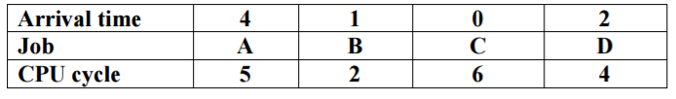

4) Assume that four jobs A-D require the CPU cycles listed below. Using the Shortest Job First algorithm, the average waiting time is **3**. Job



5) A ssume that four jobs A-D require the CPU cycles listed below. Using the Round-Robin algorithm with time slide equaling 4, the waiting time of all process is **25**

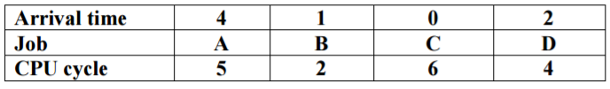

6) Assume jobs A-D arrive in quick succession in the READY queue. Using round robin scheduling with time slice equaling 4, the turnaround time for job D is **14**.

|  |  |  |  |  |
| --- | --- | --- | --- | --- |
| **Arrival time** | **0** | **1** | **2** | **3** |
| **Job** | **A** | **B** | **C** | **D** |
| **CPU cycle** | **8** | **4** | **9** | **5** |

7) Assume jobs A-D arrive in quick succession in the READY queue. Using shortest job first scheduling, the average turnaround time for each process is **8.75**.

|  |  |  |  |  |
| --- | --- | --- | --- | --- |
| **Arrival time** | **0** | **1** | **2** | **3** |
| **Job** | **A** | **B** | **C** | **D** |
| **CPU cycle** | **8** | **4** | **9** | **5** |

8) Assume jobs A-D arrive in quick succession in the READY queue. Using shortest remaining time next scheduling, the average waiting time for each process is **8.75**

|  |  |  |  |  |
| --- | --- | --- | --- | --- |
| **Arrival time** | **0** | **1** | **2** | **3** |
| **Job** | **A** | **B** | **C** | **D** |
| **CPU cycle** | **8** | **4** | **9** | **5** |

9) A ssume that four jobs A-D require the CPU cycles listed below. Using the Shortest Job First algorithm, the **B** job is run first.

|  |  |  |  |  |
| --- | --- | --- | --- | --- |
| **Job** | **A** | **B** | **C** | **D** |
| **CPU cycle** | **5** | **2** | **6** | **4** |

10) Assume jobs A-D arrive in quick succession in the READY queue. Using round robin scheduling with time slice equaling 4, the turnaround time for job C is **11**

|  |  |  |  |  |
| --- | --- | --- | --- | --- |
| **Arrival time** | **0** | **1** | **2** | **3** |
| **Job** | **A** | **B** | **C** | **D** |
| **CPU cycle** | **4** | **5** | **5** | **4** |

11) Assume jobs A-D arrive in quick succession in the READY queue. Using shortest job first scheduling, the average turnaround time for each process is **9.75**

|  |  |  |  |  |
| --- | --- | --- | --- | --- |
| **Arrival time** | **0** | **1** | **2** | **3** |
| **Job** | **A** | **B** | **C** | **D** |
| **CPU cycle** | **4** | **5** | **5** | **4** |

12) Assume jobs A-D arrive in quick succession in the READY queue. Using shortest remaining time next scheduling, the average waiting time for each process is **5.25**

|  |  |  |  |  |
| --- | --- | --- | --- | --- |
| **Arrival time** | **0** | **1** | **2** | **3** |
| **Job** | **A** | **B** | **C** | **D** |
| **CPU cycle** | **4** | **5** | **5** | **4** |

13) Assume jobs A-D arrive in quick succession in the READY queue. Using round robin scheduling (quantum=4), the average turnaround time for each job is **12.5**

|  |  |  |  |  |
| --- | --- | --- | --- | --- |
| **Arrival time** | **0** | **1** | **2** | **3** |
| **Job** | **A** | **B** | **C** | **D** |
| **CPU cycle** | **8** | **4** | **9** | **5** |

14) Five batch jobs A through E, arrive at a computer center at almost the same time. They have estimated running times of 8, 6, 2, 10, and 4 minutes. Determine the mean process average turnaround time for SJF (Shortest job first) scheduling. Ignore process switching overhead.

Step 1: Sort the jobs in ascending order based on their running times.

Job C: Running time = 2 minutes

Job E: Running time = 4 minutes

Job B: Running time = 6 minutes

Job A: Running time = 8 minutes

Job D: Running time = 10 minutes

Step 2: Calculate the turnaround time for each job.

Job C:

Turnaround time = Running time = 2 minutes

Job E:

Turnaround time = Running time + Turnaround time of previous job = 4 minutes + 2 minutes (Job C) = 6 minutes

Job B:

Turnaround time = Running time + Turnaround time of previous job = 6 minutes + 6 minutes (Job E) = 12 minutes

Job A:

Turnaround time = Running time + Turnaround time of previous job = 8 minutes + 12 minutes (Job B) = 20 minutes

Job D:

Turnaround time = Running time + Turnaround time of previous job = 10 minutes + 20 minutes (Job A) = 30 minutes

Step 3: Calculate the mean process average turnaround time.

Mean process average turnaround time = Sum of turnaround times / Number of jobs

= (2 minutes + 6 minutes + 12 minutes + 20 minutes + 30 minutes) / 5

= 70 minutes / 5

= 14 minutes

Therefore, the mean process average turnaround time for SJF scheduling is 14 minutes.